**Next:**

1 Elite drone back to the mother -> add fuel and Resource

2 Mining -> mine the asteroid ->

3 Asteroid mining out die

4 drone report back to Mothership and remove the asteroid out of the resource list

elite drone refuel?

Issues

//dronefuel = dronefuel + 5000; Can't base on frame must be distance because drone go

**once the asteroid die**

refuel

1 remove the asteroid from the Mothership resourceOjbect list, NOt by index but object??

2 reset the Elite Drone to normal Drone

3 sent scout looking for new asteroid

4 turn best Drone into new Elite Drone

//PART 2

// * If the Resource Location list is populated,

//If Resource[].count > 0

// * the Mothership should designate elite foragers to the 2 best[patches]

// While eliteForages[].count < 2

// if ther is less than 2 drones....so in otherwords if there is only 1

// Assign an Elite forager(providing there is a Resource to assign it to....and that we have a drone to assign)

// *and normal foragers to the next 3 best[asteroids].

// If Resource[].count > 2

// While foragers[].count < 3

// Assign Forager

Elite Forager

Normal Forager

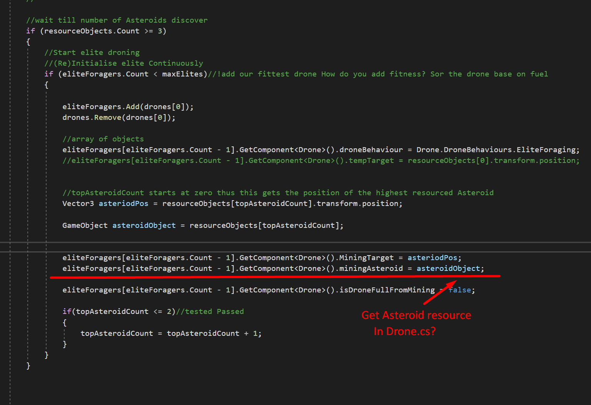

dronefuel = dronefuel - 1;//should be adjust to distance instead?

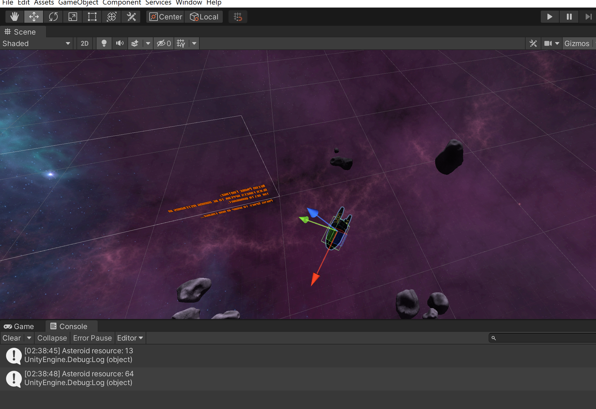

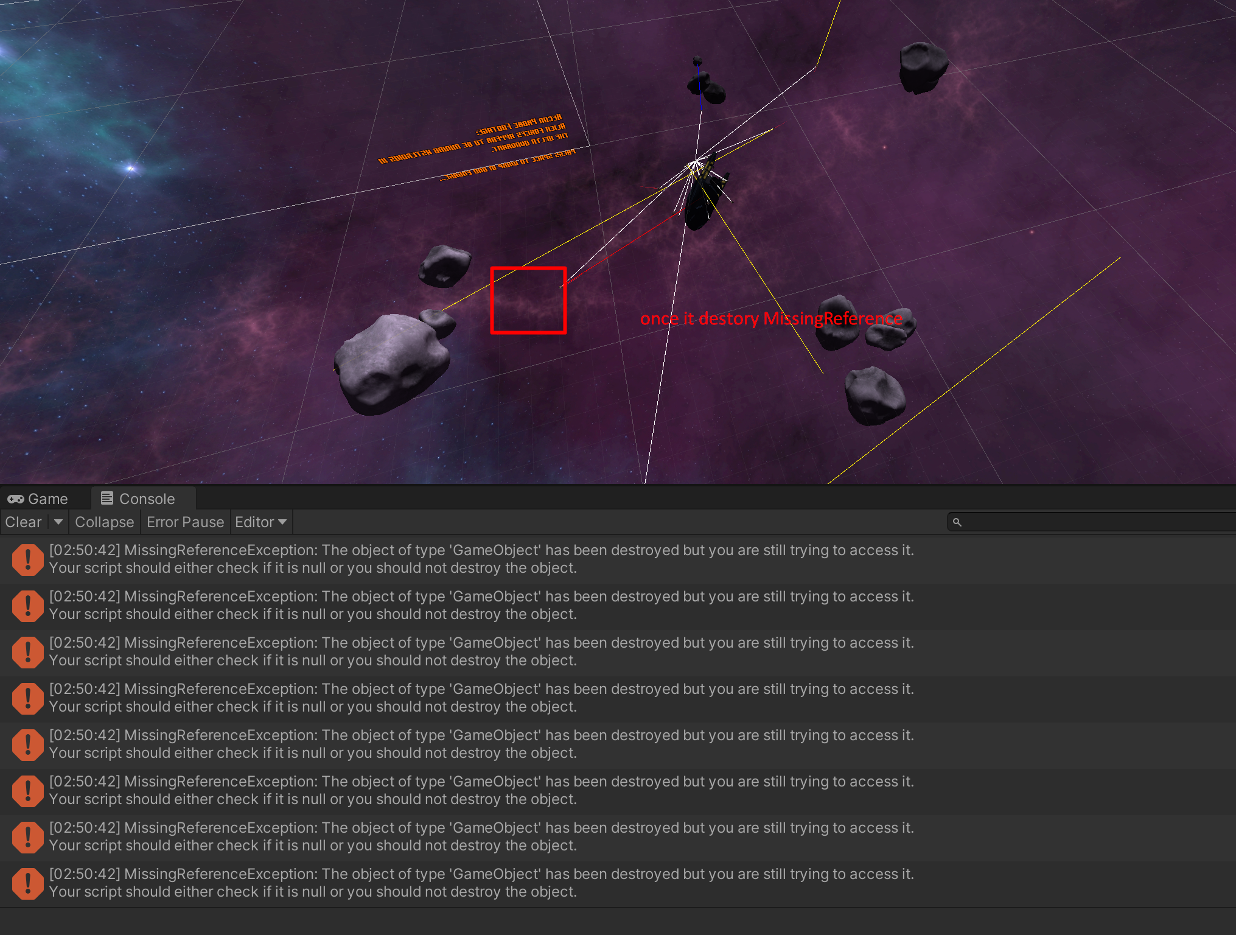

Youtube video

You need to know this! Master debugging in Unity & C#

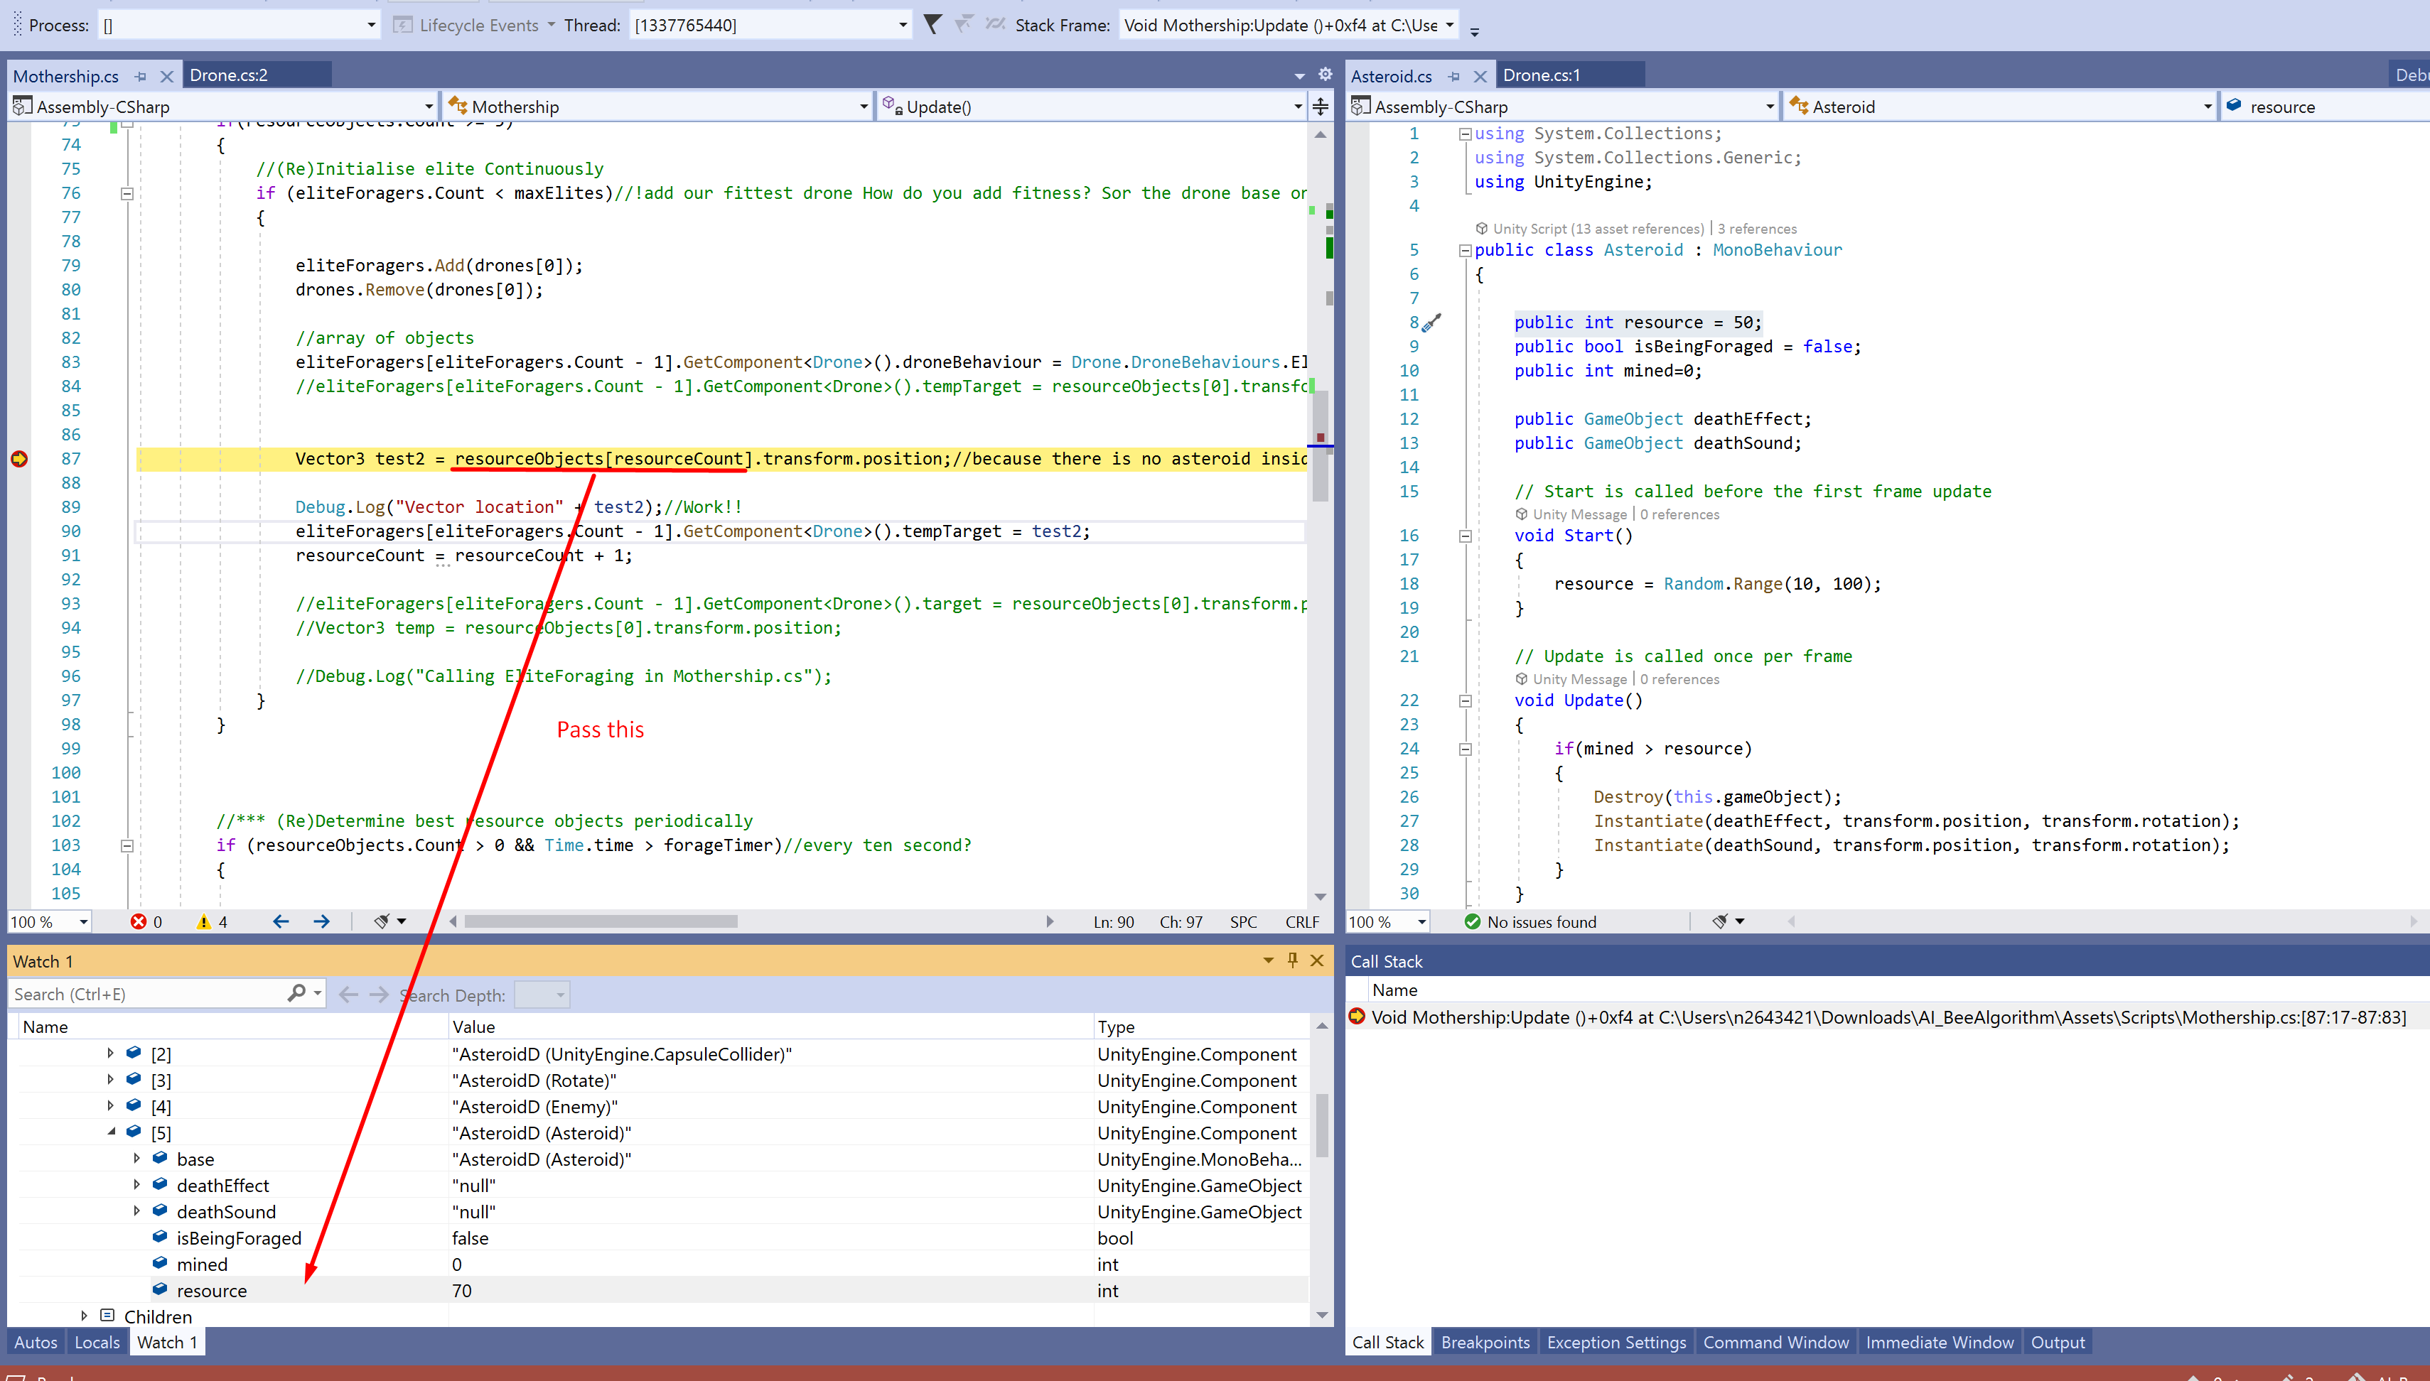

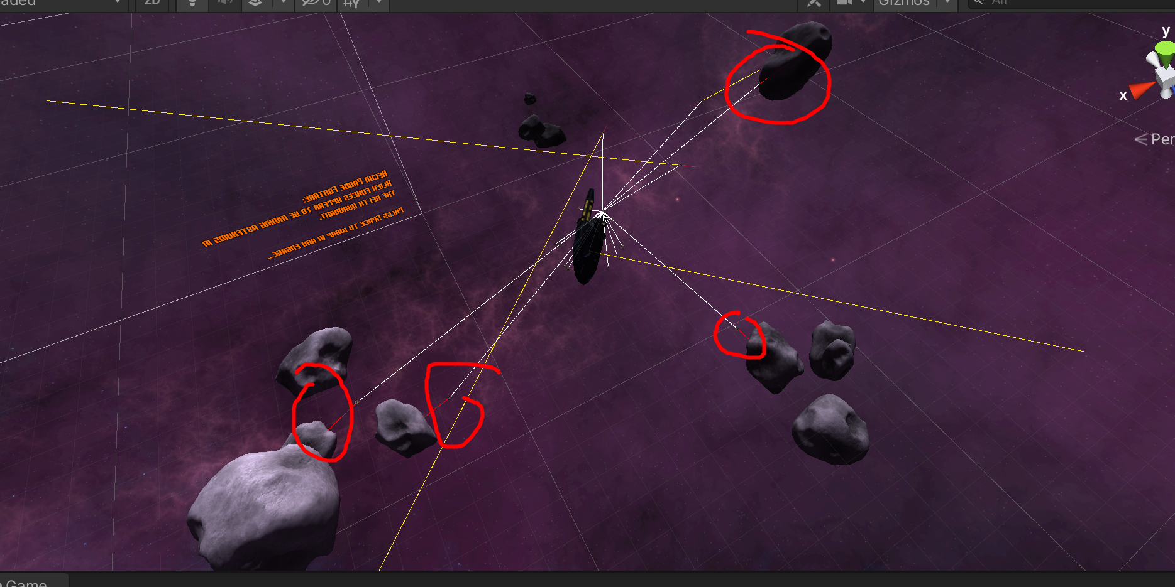

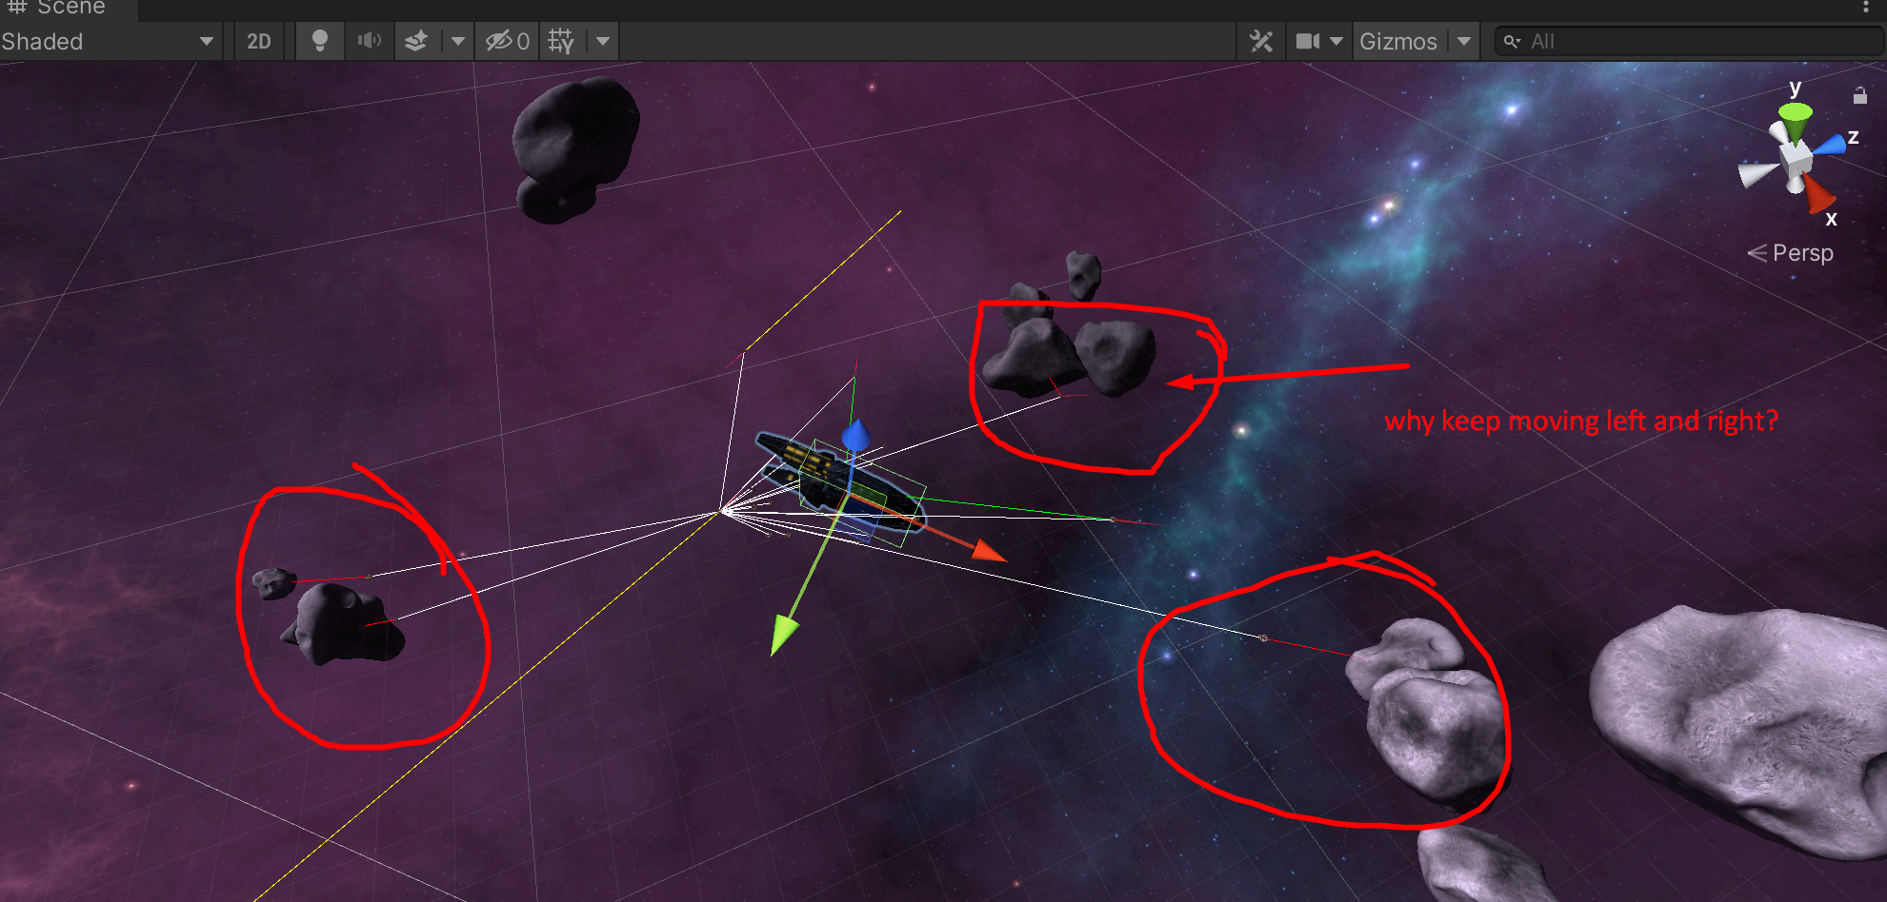

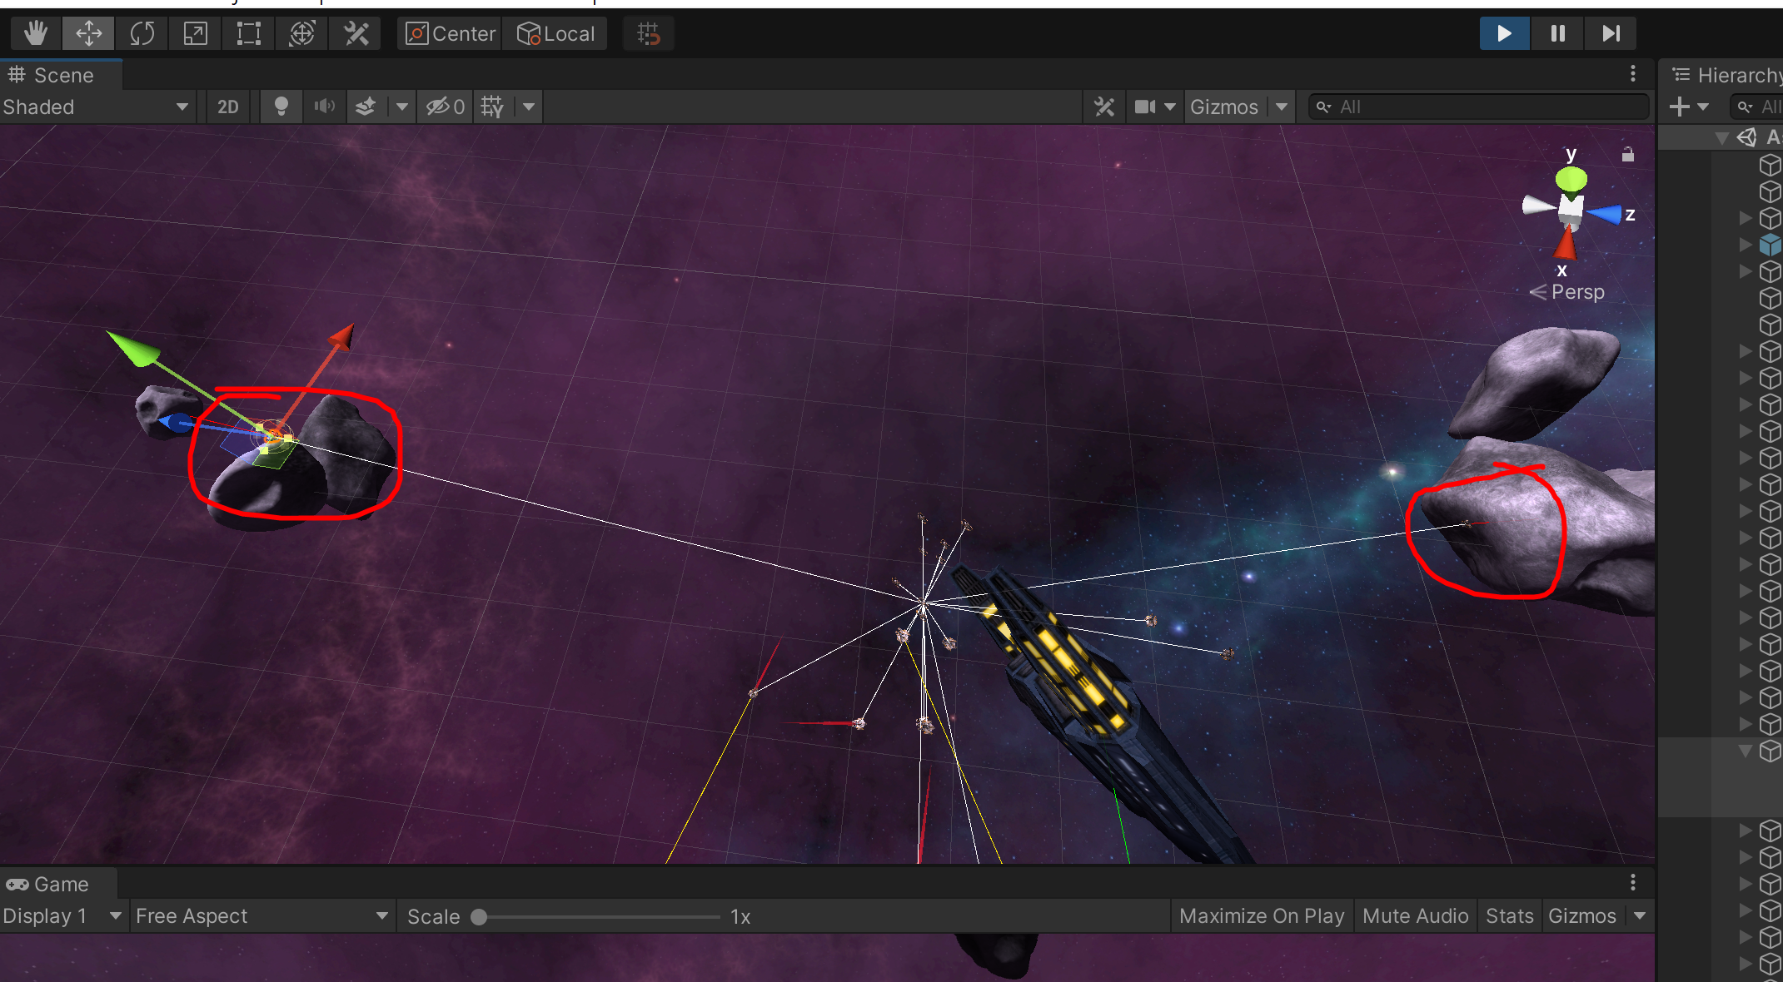

How I learned Unity without following tutorials

[**https://www.youtube.com/watch?v=vFjXKOXdgGo&ab_channel=GameMaker%27sToolkit**](https://www.youtube.com/watch?v=vFjXKOXdgGo&ab_channel=GameMaker%27sToolkit)

**continue 8:30**

**gameObject**

**resourceObjects**

**two patches <- one group of asteroid**

**100 <- only elite drone. don't want to sent every drone to this asteroid**

**89 <- only elite drone.**

**70 <- only normal drone**

**50 <- only normal drone**

**30 <- only normal drone**

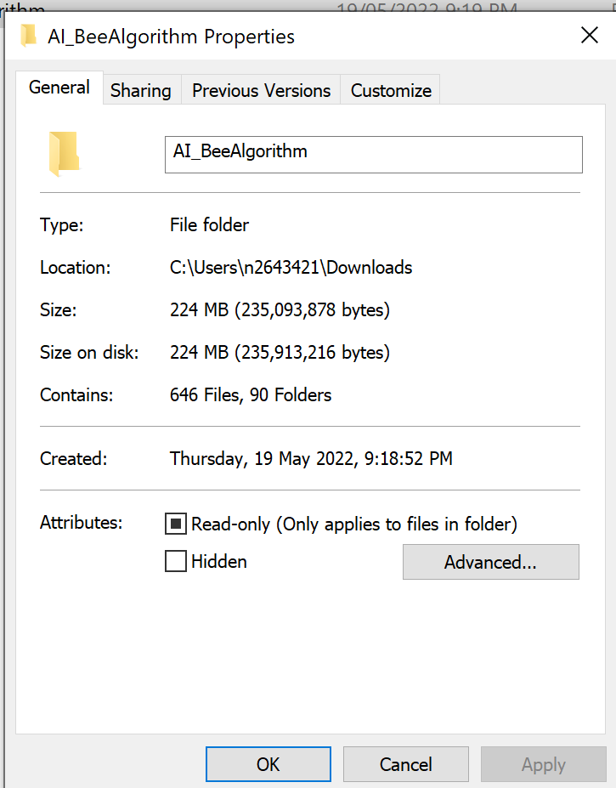

**Github download size 224mb**



Whole group

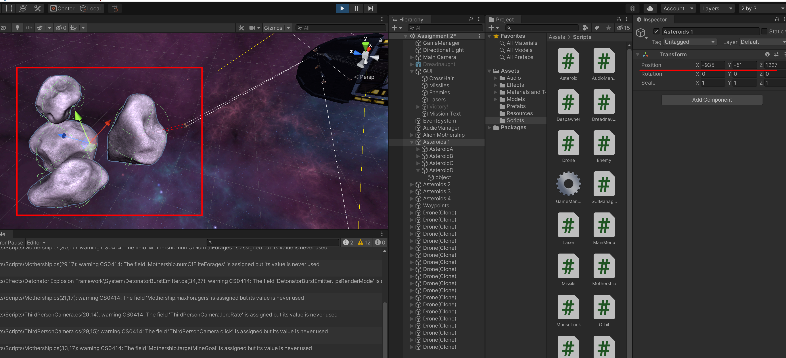

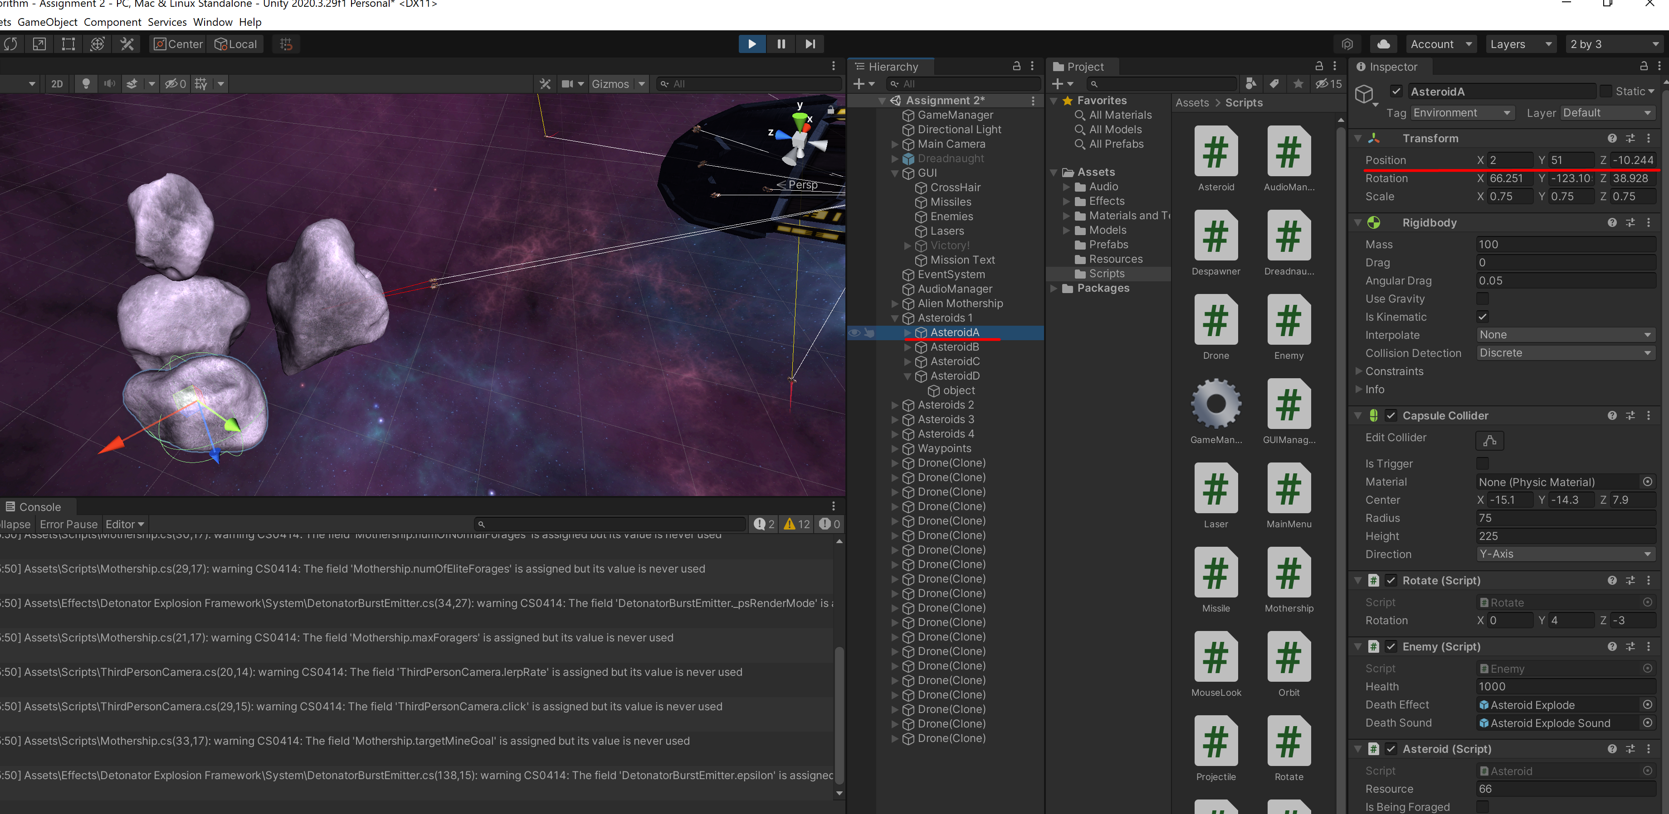

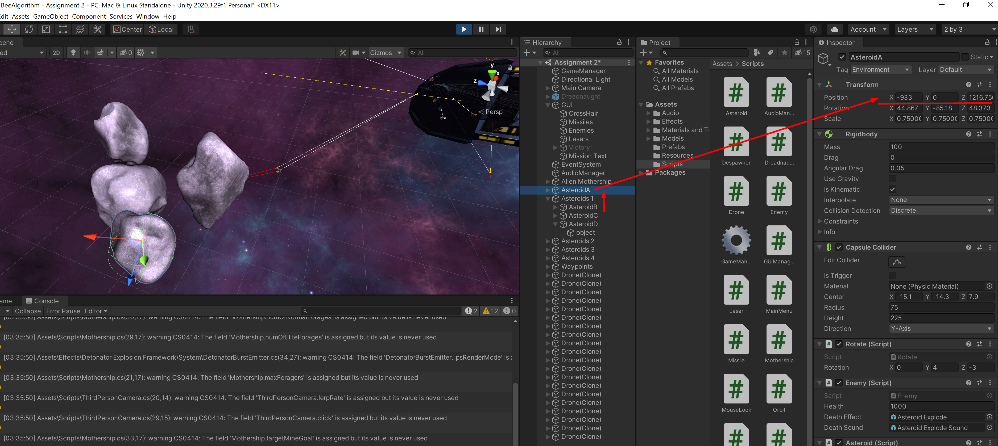

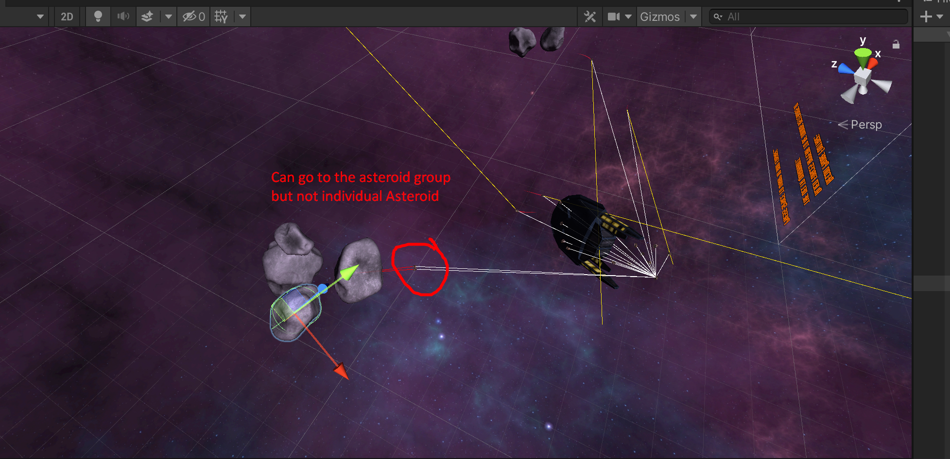

Neighbour hood shrinking

